Circuit Analysis (Lab4) Experiment 4: Implementation of Basic Parallel Circuit

Name: Sagheer Hussain Registration No: 2025-CE-109
Grade and Signature: ………………………..
CLO2  CLO3 | Use with identification the circuit components, breadboards, multimeters, power supplies, signal generators, and oscilloscopes.  Make measurements in their own constructed electric circuits.
Psychomotor/Affective | Level1  (1) | Level2  (2-3) | Level3  (4-5) | Level4  (6-7)
Report Marks (3) |  |  | Total marks (10)

Objectives: To make measurements in your own constructed parallel circuits.
Equipment required:
Power Supply, Breadboard, Connecting wires, Resistances, Multimeter.

How to make resistance measurements
Resistance is measured with the circuit’s power turned off. The ohmmeter sends its own current through the unknown resistance and then measures that current to provide a resistance value readout.

Resistance measurement procedures
Follow the steps below to measure resistance:
- Turn off the power to the circuit. Remove or isolate the component to be tested.
- Plug the test probes into the appropriate probe jacks. Note that the jacks used may be the same ones used to measure volts.
- Select the ohms function by turning the function switch to ohms. Start with the lowest setting.
- Touch the probes together to check the leads, connections and battery life. The meter should display zero or a very small amount of resistance for the test leads. With the leads apart, the meter should display OL or I, depending on the manufacturer.
- Connect the tips of the probes across the break in the component or portion of the circuit for which you want to determine resistance. If you get an OL (over limit), move to the next level.
- View the reading on the display unit. Be sure to note the unit of measurement.
- After all the resistance readings are complete, turn the DMM off to prevent the battery from draining

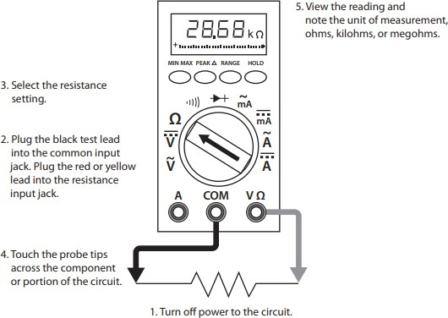
Figure 1 Using a DMM to measure resistance

How to make voltage measurements

Voltage measurements are very easy to make with a DMM. On meters with manual range selection, start with a value one setting higher than expected. An auto range DMM will automatically select the range based on the voltage present. Figure 4 shows the process.

Note:

1/ 1000 V=1mV

1000 V=1kV

Follow these steps to measure voltage:

- Select the DC or AC volts function by turning the function switch to DC or AC volts.
- Plug the test probes into the appropriate probe jacks.
- Connect the tips of the probes across the source or load.
- View the reading on the display unit. Be sure to note the unit of measurement. If you are testing DC voltage and a negative sign appears in the display, the polarity of your probes is incorrect and needs to be reversed.

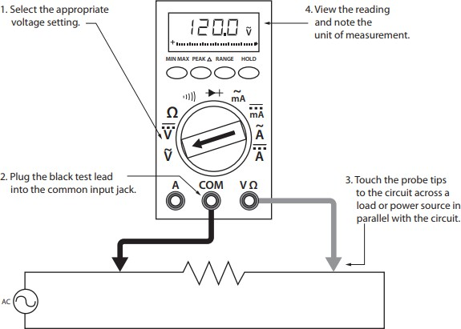

Figure 2 Using a DMM to measure voltage

How to make Current measurements

Follow the steps below to measure current:

- Turn off the power to the circuit that will be measured.
- Open the circuit by disconnecting or unsoldering a connection at a point where you wish to measure current.
- Select the DC or AC amps function by turning the function switch to DC or AC amps.
- Plug the test probes into the appropriate probe jacks. Note that the jacks used may not be the same ones used to measure volts.
- Connect the tips of the probes across the break in the circuit so that the current to be measured flows through the meter. Note that this is a series connection. Never connect the ammeter in parallel with the source or load, as this will cause a short circuit and damage the meter.
- Turn the circuit power back on.
- View the reading on the display unit. Be sure to note the unit of measurement.
- Switch power off and disconnect meter leads from the circuit.
- If testing is finished at this test point, restore the circuit by reclosing the connection. When current measurements are complete, turn the function switch to the OFF position and remove the test leads.

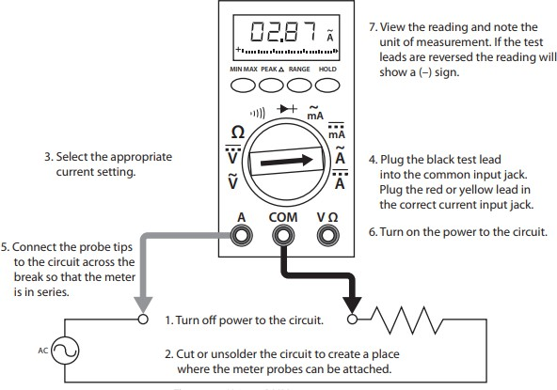

Figure 3 Using a DMM to measure current

Lab Tasks:

  - Measure the current across R1, R2, R3 and Voltage between node 2 and 7.
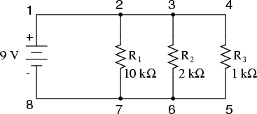
Practical Values:

R1 Current | R2 Current | R3 Current | Voltage
0.9mA | 4.5mA | 9mA | 9V

Theoretical Values:

R1 Current | R2 Current | R3 Current | Voltage
I=V/r1  =9/10k  =0.9mA | I=V/r2  =9/2k  =4.5mA | I=V/r3  =9/1k  =9mA | 9V

  - Measure the current across R1, R2, R3 and Voltage between node a and e.
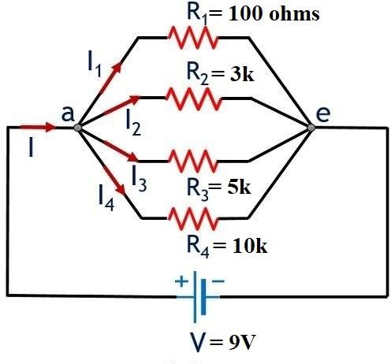

Practical Values:

R1 Current | R2 Current | R3 Current | R4 Current | Voltage
90mA | 3mA | 1.8mA | 0.9mA | 9V

Theoretical Values:

R1 Current | R2 Current | R3 Current | R4 Current | Voltage
I=V/r1  =9/100  =90mA | I=V/r2  =9/3k  =3mA | I=V/r3  =9/5k  =1.8mA | I=V/r4  =9/10k  =0.9mA | 9V

Post Lab Questions:
1. Why is the value of voltage across each resistor in parallel circuit same?
In a parallel circuit, all resistors are connected across the same power source. This means each resistor is connected between the same two points. Because of this, the voltage across every resistor is equal to the source voltage.

2. When parallel resistors are of three different values, which has the greatest power loss?
In a parallel circuit, power is given by P = V² / R. Since voltage is the same for all resistors, the resistor with the smallest resistance will dissipate the most power. This happens because it allows more current to pass through it.

3. How the current across any branch of a parallel circuit varies?
The current in each branch depends on its resistance. According to Ohm’s Law (I = V / R), a branch with lower resistance will have higher current, while a branch with higher resistance will have lower current. So, current divides inversely with resistance in parallel circuits.

4. What happens to total resistance in a circuit with parallel resistors if one of them opens (i.e., removed)?
If one resistor is removed from a parallel circuit, the total resistance increases. This is because one path for current is lost. As a result, the total current flowing in the circuit decreases.

